**CAPTAIN Moderation Data Analysis Report, 11-18-2021.**

The dataset used for this analysis consisted of 1,106 participants. Out of all 3,600 unique CAPTAIN participants, 1,188 participants had non-missing values for all 3 variables of interest: ICS Setting total, amount of ASD experience, and EBP primary outcome score. From these 1,188 participants, we excluded 82 participants (6.9%), whose SELPA and/or district were missing; 82 participants were missing districts and 60 of those 82 were also missing SELPA’s. SELPAs/districts were most likely missing in these cases because these participants were not a member of a specific SELPA and/or district.

Out of the 1,106 participants, 905 (81.8%) were female and 128 (11.6%) were male. The participants were from 111 different SELPAs and 305 different districts. The number of participants from each SELPA ranged from 1 to 53 participants, and it was the same for each district. Almost all of them were Direct Support Professionals (99.5%). Seventy one percent identified themselves as Caucasians, followed by 4.3% as Asians and 1.3% as African American, with 18.1% from mixed/other/refused categories. About half of them were younger than the age of 45 (52.8%).

The variables modeled in this report are Implementation Climate Scale (setting) total score, ASD experience, and Evidence Based Practice primary outcome. The range of ICS total is 0 to 100, with an overall mean of 38.1 (SD=21.7), and as for EBP outcome, the range is 0 to 4 with the mean 2.54 (SD=0.86). ASD experience was initially categorical, with values ranging from “Little to no experience” to “Extensive hands-on experience”, but was transformed into a 0-3 numeric scale representing increasing experience with ASD.

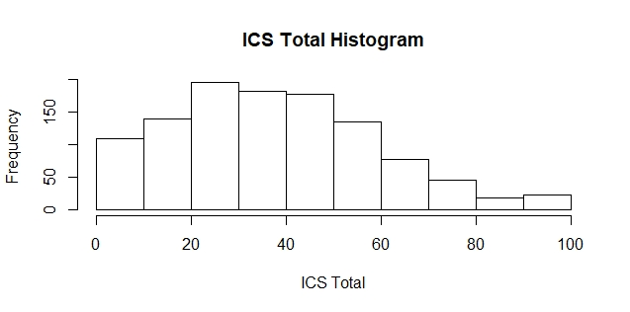Below are histograms of the variables used for the model in this report:

The analysis examined EBP outcome as a dependent variable, predicted by ICS total score, and whether the relationship between ICS total score and EBP outcome was moderated by the amount of ASD experience. Multilevel modeling was conducted in R using lme4 package (Bates, Maechler, Bolker, & Walker, 2015) in order to account for the nested nature of the data, where participants are grouped within Districts which, in turn, are grouped within SELPAs. We first examined an unconditional model, with no fixed effects, in order to assess the variances of the random effects of District and SELPA. For simplicity, District and SELPA were modeled as orthogonal random effects. As a result, 3.2% of variance in EBP outcome is accounted for by district, and 1.6% by SELPA. District and SELPA both accounted for very little variance, but were retained in the model as random effects as per the design of the study:

*Model 1: EBP outcome ~ 1 + (1|District) + (1|SELPA)*

Building on this base model, we next added ICS total score as a fixed main effect:

*Model 2: EBP outcome ~ 1 + ICS Total + (1|District) + (1|SELPA)*

Testing between the two models above, using deviance values between -2LogLikelihood scores distributed as a Chi-square, with the degrees of freedom equal to the difference in number of estimated parameters, we found that the main effect of ICS total score on EBP outcome was significant (Chi-square = 59.92, df = 1, p-value < 0.001). This result indicated that the higher ICS total score, the higher EBP outcome score, and the relationship is significant. Specifically, for every 1 point gain in ICS Setting total score, there was a respective increase in EBP Outcome scores of 0.0092 (SE = 0.0012, t = 7.93, p<.001).

Building on model 2, we next added ASD experience as second main effect:

*Model 3: EBP outcome ~ 1 + ICS Total + ASD Exp + (1|District) + (1|SELPA)*

Again, comparing models 2 and 3 revealed that ASD experience was also a significant predictor of EBP Outcome scores (Chi-square = 108.75, df = 1, p-value < 0.001). This result indicated that increased experience with ASD was significantly related to EBP Outcome scores, with a gain of 0.33 (SE = 0.031, t = 10.68, p<.001) in EBP Outcome scores with each 1 point gain in the 4-point scale of ASD experience.

After investigating the main effects, we next examined how ASD experience moderated the relationship between ICS and EBP Use by including an interaction term between ICS and ASD experience in the model. The model fitted is shown below:

*Model 4: EBP outcome ~ 1 + ICS Total + ASD Exp + ICS Total * ASD Exp + (1|District) + (1|SELPA)*

Comparing model 3 and 4, we found that the interaction effect between ICS total and ASD experience was significant (Chi-square = 7.46, df = 1, p-value < 0.01). This result indicated that as ASD experience decreased, the relationship between ICS and EBP Use became more robust. This interaction is illustrated in Figure 1 below. For individuals with no experience with ASD, EBP Outcome scores increased approximately 0.54 as ICS scores increased from 25 to 55, whereas for those with a lot of experience with ASD, EBP Outcome scores only increased 0.2 with increasing ICS scores.

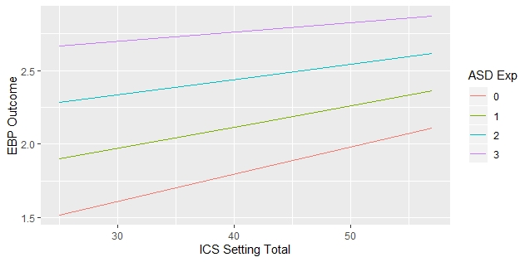**Figure 1: oderation effect of ASD experience on ICS as a predictor of EBP Outcome.**